Puru Sai Koushik
2200032991
week-4 spring-rest-handson
Create a Spring Web Project using Maven

Here we will see the output on your local host
http://localhost:8080/api/hello
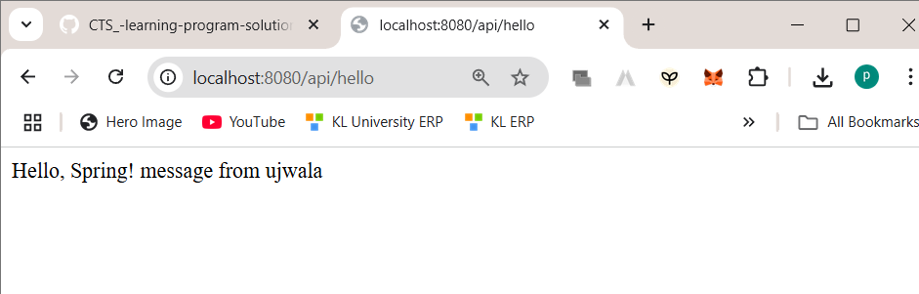

Helloacontroller.java
package com.cognizant.springlearn.controller;

import org.springframework.web.bind.annotation.GetMapping;
import org.springframework.web.bind.annotation.RequestMapping;
import org.springframework.web.bind.annotation.RestController;

@RestController
@RequestMapping("/api")
public class HelloController {

@GetMapping("/hello")
public String hello() {
return "Hello, Spring! message from ujwala ";
}
}

Application.properties
server.port=8080

